**Experiment 9**

**Shashwat Tripathi**

**D20A 64**

**Aim:** Understanding the concept of session management for web application.

**Theory: What is session management? (in detail)**

**Session management** refers to the techniques used by web applications to manage and maintain state across multiple requests made by a user. Since HTTP is a stateless protocol, every request a client sends to the server is treated as a separate event, without any knowledge of previous interactions. To overcome this, session management creates a "stateful" experience that allows web servers to remember users between requests, ensuring continuity throughout their interaction with the application.

Key aspects of session management include:

* **Session Lifecycle**:
  + A session begins when the user logs into the system or initiates some interaction.
  + The session is maintained by associating each request with a unique identifier (Session ID).
  + It ends either when the user logs out, the session expires due to inactivity, or the application decides to terminate the session.
* **Session IDs**:
  + Upon a successful login, a session ID is generated and issued to the user. This ID is used in subsequent requests to identify the user and the associated session on the server.
  + Session IDs can be stored in cookies, appended to URLs, or stored in hidden form fields.
* **Challenges**:
  + Since the session links user identity to actions on a server, securing the session from various attacks like session hijacking, session fixation, or Cross-Site Scripting (XSS) becomes essential.

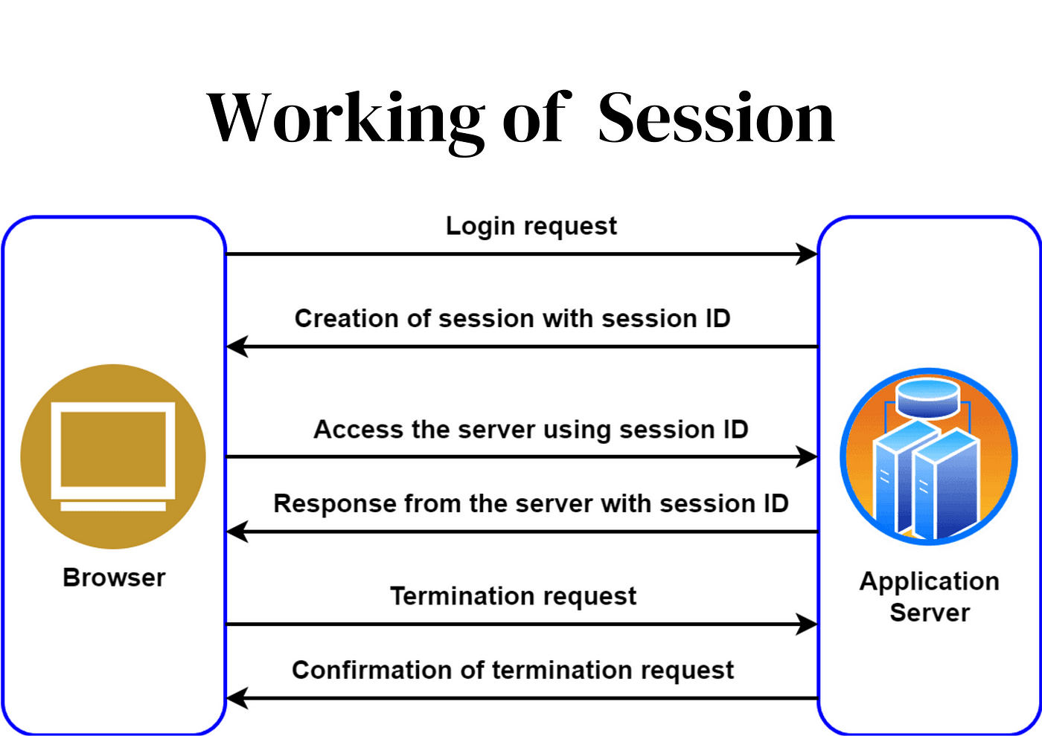

**What are the session management best practices according to OWASP?**

**OWASP** (Open Web Application Security Project) outlines session management as a critical security function, and provides a set of best practices for secure session management. These best practices help mitigate risks like session hijacking, session fixation, and other session-based attacks.

Some of the critical OWASP best practices include:

1. **Session ID Properties**:
   * Session IDs should be long, random, and unpredictable. Using a secure random number generator ensures that session IDs cannot be easily guessed or predicted by attackers.
   * Session IDs should be unique to each user and each session.
2. **Session ID Storage**:
   * Use cookies with appropriate flags to store session IDs:
     + **Secure Flag**: Ensures that cookies are only transmitted over secure, encrypted connections like HTTPS.
     + **HttpOnly Flag**: Prevents JavaScript from accessing session cookies, reducing the risk of attacks such as XSS.
     + **SameSite Flag**: Helps mitigate Cross-Site Request Forgery (CSRF) attacks by limiting how cookies are sent along with requests.
3. **Regenerate Session IDs**:
   * Regenerating the session ID after significant actions, like login or privilege escalation, helps prevent **session fixation** attacks, where an attacker fixes a session ID before login and hijacks the user’s session after login.
   * Periodically regenerate session IDs during the session lifecycle to reduce the risk of session hijacking.
4. **Session Expiry and Invalidation**:
   * **Inactivity Timeout**: Automatically terminate sessions after a predefined period of inactivity (e.g., 15-30 minutes).
   * **Absolute Timeout**: Terminate sessions after a maximum session duration, regardless of user activity (e.g., after 8 hours).
   * **Logout Mechanism**: Provide users with a visible and immediate way to log out and invalidate their session. Once a user logs out, all session data should be cleared on both client and server-side.
5. **Session Data Protection**:
   * Store minimal data in sessions. Sensitive data (such as passwords or personal details) should never be stored directly in session objects.
   * Encrypt session data if it is stored client-side (e.g., in cookies).
6. **Concurrent Session Controls**:
   * Limit the number of active sessions per user. For example, prevent users from logging in from multiple devices simultaneously or limit the number of active sessions to one.
7. **Session Activity Logging**:
   * Log important session-related events (e.g., logins, logouts, and session expiration). This can help detect suspicious activity or potential security breaches.

**Key Components of Session Management.**

**Session ID**:

* The **Session ID** is a unique string of characters generated by the server when a session starts. It is a critical identifier used to maintain user identity across multiple requests. In most cases, the session ID is stored in a cookie and sent with every request to the server, which uses it to retrieve session data.

**Session Data**:

* Session data typically consists of variables and information associated with a specific user’s interaction with an application. This may include user preferences, authentication status, shopping cart contents, or any data that should persist across multiple HTTP requests. The session data is either stored on the server or in client-side storage, depending on the type of session management used.

**Cookies**:

* Cookies are a common way to store session-related information in the user’s browser. They hold the session ID, and the server uses that ID to associate the client’s requests with the stored session data. Cookies are the most widely used method due to their simplicity and ease of integration with modern web applications.

**Session Timeout and Expiration**:

* Sessions should have an expiration mechanism to automatically terminate after a period of inactivity (e.g., 15 minutes) or after a fixed duration (e.g., 8 hours). Expiration helps mitigate risks such as session hijacking from a previously authenticated but idle user.

**Session Tokens**:

* Tokens like **JWT (JSON Web Token)** can be used as an alternative to traditional session IDs. Tokens contain user information encoded in a string and can be verified by the server without needing a central session store. This provides a stateless session mechanism.

**Session Stores**:

* For server-side session management, session data is stored on the server, typically in memory or a database. Common session stores include Redis, Memcached, or database-backed storage. Each session store has different performance and scalability characteristics.

**Session Validation**:

* On every request, the server must validate that the session ID matches a valid, active session. If the session ID is invalid or has expired, the user is typically logged out and redirected to a login page.

**Types of Session Management.**

1. **Cookie-Based Session Management**:
   * Cookies are widely used for session management. When the user logs in, the server generates a session ID and sends it to the client as a cookie. With each subsequent request, the client sends the session ID back to the server via the cookie. The server uses this session ID to retrieve session data from its store.
   * Cookies are convenient but come with security risks, especially if not properly secured (e.g., they can be stolen via XSS attacks or leaked through HTTP).
2. **Token-Based Session Management (JWT)**:
   * In token-based session management, the server generates a token (usually a JWT) upon authentication. This token is sent to the client and can be stored in local storage, session storage, or cookies.
   * Unlike cookie-based sessions, JWT tokens contain encrypted data about the session (e.g., user information), which can be decoded and verified by the server without needing server-side storage.
   * Token-based sessions offer a stateless mechanism, meaning the server does not need to maintain a session store.
3. **URL-Based Session Management**:
   * In this approach, the session ID is appended to each URL as a query parameter. The server retrieves the session ID from the URL and associates it with the corresponding session data.
   * While simple to implement, URL-based session management is considered insecure because the session ID can be exposed in browser history, bookmarks, or logs. Attackers may also intercept or modify session IDs in URLs.
4. **Server-Side Session Management**:
   * In this type, session data is stored entirely on the server, with only a reference (the session ID) being sent to the client. This allows the server to control and secure the session data, while the client only manages the session ID.
   * Server-side session management is considered more secure than client-side alternatives like token-based sessions, but it can be less scalable due to the need for session storage on the server.

Each session management type offers trade-offs between security, scalability, and ease of implementation. For example, cookie-based sessions are simple but require careful security measures, while token-based (JWT) systems are stateless and more scalable but introduce other challenges, such as secure token storage on the client side.

**Conclusion:** In this experiment, we explored the concept of **session management** in web applications, which is essential for maintaining user state across multiple requests in a stateless environment like HTTP. By implementing secure session practices and understanding various session management techniques, we can ensure seamless and secure user experiences while protecting against common security vulnerabilities like session hijacking and fixation.